**St John the Evangelist CE Primary School**

**Attendance Policy**

**Vision Statement:**

***St. John’s is a caring, Christian community striving to support its members to achieve their God given potential. Exploring our unique gifts and raising aspirations, we prepare our children for the challenges of the modern world. Following Jesus’ example, we seek to grow good people who can make a difference.***

Attendance Policy Statement

Good attendance is essential if pupils are to take full advantage of school and gain the appropriate skills, which will equip them for life.

At St Johns we aim to achieve good attendance by operating an attendance policy within which staff, pupils, parents, local community and the Attendance Support Team from the local authority can work in partnership. The school will monitor attendance and ensure quick and early intervention if a problem is identified.

All staff will encourage good attendance and will liaise with home and partner agencies if this is appropriate. Good attendance will be seen as an achievement in its own right and recognised as such by the school. The attendance policy is based on the premise of equal opportunities for all.

###### Children at St John the Evangelist Primary School come into school in order to start work at:- 8.45 a.m.

###### Registers are taken electronically and remain open for the registration period until 8.55 am.

###### Any child who arrives after the register has closed will be marked as late. (L)

###### Pupils who arrive after 9.00 will be marked as unauthorised unless for a medical appointment. (U code)

###### Registers are marked in accordance with the latest SIMS codes.

###### Parents or carers are requested to contact school by phone on the first day of absence.

###### The attendance team (school office, pastoral lead and headteacher) will contact families of pupils who aren’t in attendance but haven’t informed school.

Completing the Register

###### The school uses electronic registers .If a member of staff is not able to access the SIMs system to complete the register they are to use the laminated class list to complete the register and inform the admin staff that the SIMs system was not accessible. All staff are required to note any children absent on the laminated class list as this is used in the event of an emergency such as a fire/fire practice.

* Registers provide the daily record of the attendance of all pupils; they are legal documents that may be required in a court of law, for example as evidence in prosecutions for non-attendance at school

Procedure

* Children or young people are expected to attend school for the full 190 days of the academic year, unless there is a good reason for absence.

There are two types of absence:

* + Authorised (where the school approves pupil absence)
  + Unauthorised (where the school does not approve absence)
* It is expected that parents will provide an explanation if the child or young person is absent on the first day the absence occurs. This can be by letter, telephone, text, personally at the office or by appointment
* If contact, explaining the child or young person’s absence, fails to be made by parents or carers, then the school will contact the home by text on the initial day, following this with a phone call on subsequent days. School may phone home on the first day of absence if we are concerned for the child’s welfare.
* Persistent absence. The school is expected to tackle persistent absence rigorously. Recent changes by the DFE mean that the definition of persistent absence has changed. Any child whose attendance is less than 90% could be classed as a persistent absentee.
* The Head teacher will regularly remind parents of the importance of good attendance and punctuality through the newsletter.
* Attendance will be rewarded in school, for example, through a class of the week reward.

Lateness

###### Children at St John the Evangelist Primary School come into school in order to start work at:- 8.45 a.m.

###### Registers are taken electronically and remain open for the registration period until 8.55 am.

###### Any child who arrives after the register has closed will be marked as late. (L)

###### Pupils who arrive after 9.00 will be marked as unauthorised unless for a medical appointment. (U code)

###### Pupils who are consistently late disrupt not only their own education but also that of others. Where persistent lateness gives cause for concern further action may be taken.

Where pupils SEND needs mean that arriving punctually may be difficult school and home will discuss support and this will be noted in the school support plan. An agreement may be reached to amend the agreed start time in exceptional circumstances.

Medical Evidence

Pupil illness and occasional medical appointments do happen. However where a child’s attendance is cause for concern you may be asked to provide medical evidence of your child’s attendance at an appointment – this might include a note from the doctors/dentist or copy of the prescription.

Pathway for parental responsibility measures (unauthorised absence)

* Concerns about attendance are monitored daily, weekly, half termly and annually. Where school is concerned about attendance action will be taken.

If the child/YP does not attend school as expected and no reason to authorise the absence is established, then the child will be coded in the register with an unauthorised code.

Transition timetable

Occasionally a pupil may find school very difficult and a part time table may be required for a limited period to support a pupil to cope with school. This should be time limited, with support and with the aim of returning a pupil to full time education. This should not be used to manage behaviour. School will focus on guidance set out in Emotionally Based School Non Attendance.

School will work in consultation where a transition timetable would be appropriate, agree a plan and record the timetable with the LA.

School will endeavour to follow transition timetable best practice guidance.

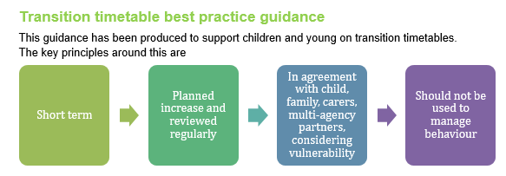

Consultation Process:

* 1. School Staff will be invited to raise any concerns or suggest proposed changes, which are deemed supportive of the aims of the policy.
  2. The Governing Body:

The curriculum committee will meet to discuss this policy and make any changes which are deemed supportive of the aims of the policy. The final policy, after consultation will be presented for approval to the whole Governing Body.

* 1. The Parents: Parents will be advised of our policy on attendance:
     + When their children first start at our school
     + Through newsletters
     + On the school website
  2. The Children .Children will be advised of our policy on attendance:
* In assemblies
* In the classroom
* During appropriate areas of the curriculum.

Leave of Absence (holidays) during term time

Parents are strongly urged to avoid booking a family holiday during term time. Parents do not have the right to take their child out of school for such a holiday. Taking your child out of school for a holiday could result in a fine. Only In exceptional circumstances a leave of absence may be granted. (Please see additional information on taking your child on holiday in term time)

What can parents do to help?

* Let the school know as soon as possible why your child or young person is away
* Send a note when your child returns to school
* Try to make appointments outside school time
* Do not allow your child to have time off school unless it is really necessary

If you are worried about your child’s attendance at school what can you do?

* Talk to your child; it may be something simple
* Talk to the Head teacher and staff at the school
* Talk to the Attendance Support Officer

You may contact the Attendance Support Officer, who will work with you and the school to resolve the situation.

The school aims to have ALL children or young people attending regularly and punctually and parents need to know that should their child fail to attend in this way then the matter will be referred to the Education Welfare Service.

Parents also need to be aware that Cheshire East Council in conjunction with the School are operating Fixed Penalty Notices for non-attendance.

In developing this Attendance Policy we have taken into account the fact that Cheshire East is an ethnically diverse community. The school has incorporated practice, which guards against disadvantaging any sections of the community and improving the performance of underachieving pupils is a key priority.

The school understands the need for on-going communication with parents and pupils regarding this policy, particularly those new to the school.

Attendance Policy Group members:

|  |  |  |
| --- | --- | --- |
| Name | Role | Responsibility |
| Pat Mark Harrison | Head teacher | To monitor the attendance throughout the school |
| Charlotte Duffy and Lindsey Earnshaw | *Admin officer* | To monitor the attendance situation of individual children or young people |
| Mark Harrison | *Headteacher* | To raise the level of attendance of those children or young people identified as being at risk |
| Alison Mottram | *Family coordinator* | The welfare of children or young people in school |
| D Tomlinson | Governor | To keep a check on the general situation |
| Attendance Support Officer | *ASO* | To support the school to achieve its objectives by following the Local Authority Guidelines. |

Monitoring and review

This policy is monitored by the Full Governing Body and will be reviewed in two years, or earlier if necessary.

Policy reviewed and approved by Full Governing Body

Chair of Full Governing Body ______________________________

**APPENDIX A – Letters**

**Letter 1: Attendance**

[Add school letter header]

[Insert Date]

Dear [Parents name],

It has been brought to my attention that your child has not been attending regularly at school. According to the Attendance Register, [Child’s name] attendance is currently [insert %], this is below the schools expected attendance.

[Child’s name] currently has [aim to send on 4] unauthorised sessions, if this reaches 10 unauthorised sessions within 2 half terms then school can apply to the Local Authority to issue you with a Penalty Notice warning period, which could result in each parent receiving a £60.00 fine, increasing to £120.00 if not paid within 21 days.

I must remind you that S.444, Education Act 1996 requires you to make sure that your child attends school, on time, every time the school is open. I am writing this letter to give you an opportunity to make sure that from now on and in future, your child attends school regularly.

If your child continues to not attend regularly, a referral will be made to the Local Authority to pursue further action.

These interventions may include,

(A) Issuing you with a Fixed Penalty Notice under S.444A Education Act 1996 which will make you liable to a penalty of up to £120. **(As above)**

(B) Initiating legal proceedings in the Magistrates Court under S.444(1) Education

Act 1996. If convicted under this section, you may be fined up to £1000.

(C) Initiating legal proceedings in the Magistrates Court under S.444(1A) Education Act 1996. If convicted of this offence you may be fined up to £2,500 or be sent to prison for up to 3 months or both.

To avoid Local Authority intervention, please ensure your child attends school regularly and on time.

If there are any issues that may be impacting on your child’s attendance, please contact Mark Harrison or Ali Mottram to discuss further.

Yours sincerely,

M Harrison

Headteacher

**Letter 2: Attendance**

[Add school letter header]

[Insert Date]

Dear [Parents name],

It has been brought to my attention that your child has not been attending regularly at school. According to the Attendance Register, [Child’s name] attendance is currently [insert %], this is below the schools expected attendance.

[Child’s name] currently has [aim to send on 8] unauthorised sessions, if this reaches 10 unauthorised sessions within 2 half terms then school can apply to the Local Authority to issue you with a Penalty Notice warning period, which could result in each parent receiving a £60.00 fine, increasing to £120.00 if not paid within 21 days.

I must remind you that S.444, Education Act 1996 requires you to make sure that your child attends school, on time, every time the school is open. I am writing this letter to give you an opportunity to make sure that from now on and in future, your child attends school regularly.

If your child continues to not attend regularly, a referral will be made to the Local Authority to pursue further action.

These interventions may include,

(A) Issuing you with a Fixed Penalty Notice under S.444A Education Act 1996 which will make you liable to a penalty of up to £120. **(As above)**

(B) Initiating legal proceedings in the Magistrates Court under S.444(1) Education

Act 1996. If convicted under this section, you may be fined up to £1000.

(C) Initiating legal proceedings in the Magistrates Court under S.444(1A) Education Act 1996. If convicted of this offence you may be fined up to £2,500 or be sent to prison for up to 3 months or both.

To avoid Local Authority intervention, please ensure your child attends school regularly and on time.

If there are any issues that may be impacting on your child’s attendance, please contact Mark Harrison or Ali Mottram to discuss further.

Yours sincerely,

M Harrison

Headteacher

**Letter 2 (to send if deemed necessary): Attendance**

Dear Parents

ATTENDANCE – CHILD’S NAME

You were informed by letter on the _________ that there was concern with regard to your child’s attendance.

As there has been no improvement, I would like to invite you to meet with me __________ (Attendance Support officer) and ___________ to discuss this and also to see what help school can offer you.

I have made an appointment for you on:

Date:________________ Time:________________

If this date or time is inconvenient for you, please contact the school office to re-arrange the appointment.

Yours sincerely

**Letter 3: Attendance**

Dear Parents

ATTENDANCE – CHILD’S NAME

Unfortunately, despite school support your child’s attendance has still not improved.

Therefore your case will now be transferred to our Attendance Support Officer, __________________ who will contact you shortly.

Yours sincerely

**Letter 1 - punctuality**

**Child’s Name** ______________________________ Class ______________

Dear Parent

Your child’s punctuality is currently giving cause for concern.

Late arrivals at school result in children or young people missing the beginning of lessons and disturbing the rest of the class when they arrive. All children or young people are expected to arrive in school between 8.50 a.m. and 9.00 a.m. Every day. Please make sure that your child arrives at the correct time.

We will continue to monitor punctuality, and hope to see an immediate and sustained improvement. If there are particular problems, which we might help with, please do not hesitate to contact either your child’s teacher or myself.

Yours sincerely

**Letter 2 - punctuality**

**Child’s Name** ______________________________ Class ______________

Dear Parent

Further to my recent letter, continued monitoring shows that there has not been sufficient improvement in your child’s punctuality and if your child continues to arrive late for school I will have to refer the matter to the Education Welfare Officer.

It is important that your child attends school punctually in order to make progress. It is also your legal duty to ensure your child’s regular and punctual attendance at school.

Please be aware that unauthorised absences could lead to the involvement of the Education Welfare Service and/or the issuing of a Fixed Penalty Notice that if remains unpaid could lead to a prosecution.

Yours sincerely

**Appendix B**

TAKING CHILDREN ON HOLIDAY DURING

TERM TIME

A guide for parents and carers

**Frequently asked questions**

**Am I entitled to take my child out of school for a family holiday?**

No. Parents have a legal duty to ensure that their children attend school or the

alternative provision on a regular basis.

The Education Act 1996 makes it a criminal offence for a parent to “fail to secure their child’s regular attendance at the school”

The amendments to the 2006 Regulations remove any reference to family holidays,

extended leave and the statutory threshold of ten school days.

The amendments make clear that **Head Teachers may not grant any leave of**

**absence (holiday) during term time unless there are exceptional circumstances**

The amendments give **parents no entitlement** to take their child out of school for a holiday in term time

The Head Teacher and Governing Body will determine what amounts to exceptional

Circumstances

**If we decide to take a holiday during term time what should we do?**

The parent/carer with whom the child resides must apply in writing to the school

The letter/application must explain the exceptional circumstance surrounding the

request for the leave of absence

**What will the school do then?**

The Head Teacher will determine whether the exceptional circumstance ruling applies, if not the application will be declined

o Only the Headteacher (or the Deputy) has the power to approve leave of absence

applications. When making the decision the protocols and criteria laid down in the

school’s attendance policy must be followed.

o Each academic year, schools inform parents/carers via a letter, newsletter or

some other communication; that they may receive a Fixed Penalty Notice if their

child has unauthorised absences in term time

You will receive a written response from the Headteacher (or the Deputy) letting you

know if your application has been approved.

If the holiday goes ahead after the application has been declined the absence will be

recorded as unauthorised.

**What will happen if the absence is unauthorised**?

The school will decide if a Fixed Penalty Notice should be issued.

If the school decide that a Fixed Penalty Notice is to be issued you will receive a letter from the school advising that it has referred the matter to the Local Authority and that a Fixed Penalty Notice may be issued;

The school will inform the Local Authority that a Fixed Penalty Notice needs to be

Issued A Fixed Penalty Notice will be sent to you, accompanied by an explanatory letter. The Notice gives you the opportunity to pay a penalty fine instead of being prosecuted in the criminal courts

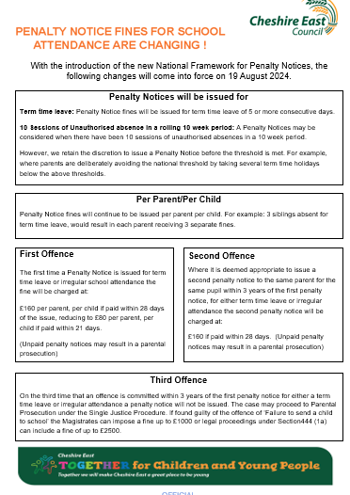

Payments will **not** be accepted after the 28th day and payments **cannot** be paid in part or by instalments

**Each school has a designated Education Welfare Officer who can be contacted**

**through school. You can also telephone the main office.**

**Tel: 01270 375277**

**Website**: [www.cheshireeast.gov.uk/ews](http://www.cheshireeast.gov.uk/ews)

**Other leaflets are available to support you:**

Taking action to improve attendance – explaining legal action - a guide for parents and

carers

Helping your child to attend school. The role of the EWO- a guide for parents and carers

*The expression “parent”, in relation to a child or young person, includes any person who is*

*not a parent of the child but who has parental responsibility for him/her, or who has care of*

*the child.*

**Appendix C: SIMS attendance codes**

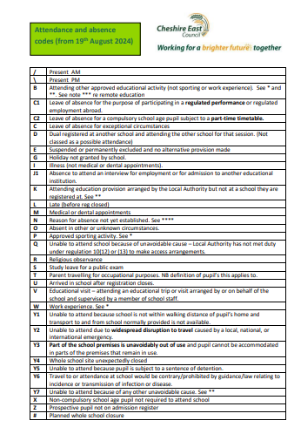

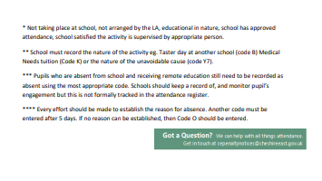

**Appendix D**

**Emotionally Based School Non Attendance Action Plan**

|  |  |  |  |
| --- | --- | --- | --- |
| **Name** |  | | |
| **Year Group** |  | **Date Started** |  |
| **Collaborators** |  | | |

**Push and Pull Factors**

|  |  |  |
| --- | --- | --- |
|  | **Push**  **(away from the environment)** | **Pull**  **(to the environment)** |
| **From/to**  **School** |  |  |
| **From/to home** |  |  |

**Functions of non-attendance (tick that apply)**

|  |  |
| --- | --- |
|  | **Function 1** To avoid things at school that make them feel anxious/sad and/or overwhelmed (including sensory over-stimulation) |
|  | **Function 2** To avoid difficult social situations or being evaluated |
|  | **Function 3** To gain attention from, or remain in close proximity to carers/family |
|  | **Function 4** To gain tangible rewards outside of school (e.g. shopping) |